# **HOST STATIC WEBSITE ON AWS**

ANKIT KUMAR RAI  
*CHANDIGARH UNIVERSITY* BUXAR , BIHAR  
 [20BCS4144@cuchd.in](mailto:20BCS4144@cuchd.in)

*ISHITA GUPTA*  
*CHANDIGARH UNIVERSITY*AMBALA,HARYANA  
[20BCS4048@cuchd.in](mailto:20BCS4048@cuchd.in)

*HARDIK*  
*CHANDIGARH UNIVERSITY*ROHTAK, HARYANA  
[20BCS4123@cuchd.in](mailto:20BCS4123@cuchd.in)

*ADITYA RAJ*  
*CHANDIGARH UNIVERSITY*BUXAR,BIHAR  
20BCS4140@cuchd.in

*Abstract*—

***It’s almost impossible to overstate the importance of website ownership to businesses, large and small alike. The Internet gives even the smallest of startup companies a chance to connect with millions of potential customers. A well-designed small business website is your best chance of making a lasting impression on your target audience. Nowadays mostly everyone probably knows the importance of having their business on the internet. AWS itself provides a free tier type of access for one year for new users to try different services. They provide almost all types of infrastructure services required for internet-connected audience and businesses. The simplest form of website architecture is the static website, where users are served static content. Some examples include brand microsites, marketing websites, and intranet information pages. Static websites are straightforward, but they can still have demanding requirements in terms of scalability, availability, and service-level guarantees. For example, a marketing site for a consumer brand may need to be prepared for an unpredictable onslaught of visitors when a new product is launched. This paper cover comprehensive architectural guidance for developing, deploying, and managing static websites on Amazon Web Services (AWS) while keeping operational simplicity and business requirements in mind. We also recommend an approach that provides 1) insignificant cost of operation, 2) little or no management required, and 3) a highly scalable, resilient, and reliable website. This paper first reviews how static websites are hosted in traditional hosting environments. Then, we explore a simpler and more cost-efficient approach using Amazon Simple Storage Service (Amazon S3). Finally, we show you how you can enhance the AWS architecture by encrypting data in transit and to layer on functionality and improve quality of service by using Amazon CloudFront.***

*Keywords*— *Web application, Wordpress, Amazon Cloud, EC2, (AMP) stack, Putty emulator, S3*

1. INTRODUCTION

Web application is a Web site where user input (navigation through the site and data entry) affects the state of the business: beyond, of course, access logs and hit counters. In essence, a Web application uses a Web site as the front end to a business application,

A web application (web app) is any application software that runs in a web browser and is created in a browser supported programming language (such as the combination of JavaScript, HTML and CSS) and relies on a web browser to render the application. The main problem is that when multiple users need to use any type of web applications such as Blogger to watch video or to share post in the same time , they will face difficulties because the high loading on main server. To solve this problem we host this web application on Amazon Cloud to provide special server to this web application.

An explorer when leaves his home to travel to a location, he had only the belongings that he carried and the money he would all through the trip. Only when reached the location he would start looking for hotels and rent the most affordable in that locality, then go on to explore that place either with an overly expensive guide or without the guide staking the safety and full potential of exploration of that trip. This system is not efficient and needs to be changed.

There’s a need of a third-party team which can lookout a most affordable and efficient travel plan for you and not only devise that plan but provide that travelling package plan to you. The travelling system is all about the use of proper information about a location and how to organize that data in a working format which is efficient and compatible to the user. Better knowledge helps the traveler to have some ease in the journey. With their trip being taken care of by the package manager, the traveler can enjoy the trip to its full extent without any care of staying, eating, etc. They can also share their reviews about how the travelling experience was and if the feedback is bad, improvements can be made in that matter.

The package tour industry is often high risk, high breakeven, high-quality product, and competitively priced. As a result, thorough tour planning and market research are necessary for tour management. However, before a tour is created, the tour manager should consider a few elements that are essential to the planning process. The satisfaction of the visitor is significantly impacted by these variables. The primary elements are:

* Purpose of Tour
* Choice of Destination
* Tourist Budget
* Legal requirement
* Types of Tourist Accommodation
* Tour Period
* Departure and Stay Information
* Tour price; inflationary condition
* Tour References Tools
* Tour features – political Study
* The relationship between the host and tourist generating nation

By offering as many specialized ideas as possible, we hope to assist tourists in finding destinations and journeys that best suit their tastes. Users won't need to compromise on their preferences or considerations thanks to this website, which also eliminates the time-consuming job of conducting online research.

Crucial management decision-making area in the development and planning of tours is this one. The tour management begins talks with the principals' suppliers for a standard contract after a decision has been reached on the destination's date, duration, and the number of passengers to be carried throughout the trip.

Negotiation is the process of discussing the terms, conditions, and costs of the various parts of a trip package with the major suppliers. It results in a legal or informal contract between them when both sides are happy.

All these requirements are needed to be met, so the factor of user satisfaction can be checked off the list. And this list of requirements was kept in mind while manufacturing of the Website. It has all the aspects of almost zero inconvenience to the user and taking all the responsibilities of the user such as tour period, staying, budget negotiation, any legal requirement, etc.

On the installation part of the website, we need to host it and give access to our website publicly so that people can visit the website and can start travelling. Now, hosting the website is the main most part, and for our convenience we chose AWS for the hosting of our website.

You may benefit from running in AWS's security, scalability, cost, and agility with this AWS architecture. The top-notch infrastructure and security operations of AWS are advantageous for this design. The website is prepared for traffic surges thanks to Auto Scaling, so you are ready for product launches and viral websites. With AWS, there is no need to over-provision for peak capacity because you only pay for what you use. Additionally, because AWS services are scalable, you get greater agility. Because you don't have to manage the infrastructure, you have more time and money to invest in creating value that differentiates your company.

|  |  |  |  |  |
| --- | --- | --- | --- | --- |
| Sr. no | Site Name | | Language | Limitation |
| [1] | Goibibo | | HTML, CSS, Javascript , Nginx, Nodejs, Apache, Amazon, Cisco, Akamai | There may be a possible lack of co-ordination with tourism entities.  , Too many players in online booking area  and Internet penetration still low. |
| [2] | Booking | | HTML5,CSS , JAVA, Javascript, JQuery, Nginx, Proofprint, Microsoft UET | If you’re on a budget, hotels are usually poorly located and can often be sterile and less spacious |
| [3] | Makemytrip | HTML,JQuery,  JavaScript,  ASP.NET, Apache,  Nginx,PHP,Drupal, Amazon,Cisco | | The cancellation and refund  process is also undependable, and it takes a long time to get their  refund. |
| [4] | Tripadvisor | | HTML,JQuery,  JavaScript,  Wordpress, Envoy,Fastly | It have very little control over the kinds of reviews that are posted about them on TripAdvisor |
| [5] | Agoda | | PHP, Wordpress, WooCommerce, Javascript,JQuery, Underscore,  Apache , Nginx,  Unix, Litespeed,HTML , CSS ,Microsoft | Sometimes, it can take a while for the hotel you’ve booked to receive the confirmation from Agoda. and service charges can end up increasing the price significantly. |

II. METHODS

Identify applicable funding agency here. If none, delete this text box.

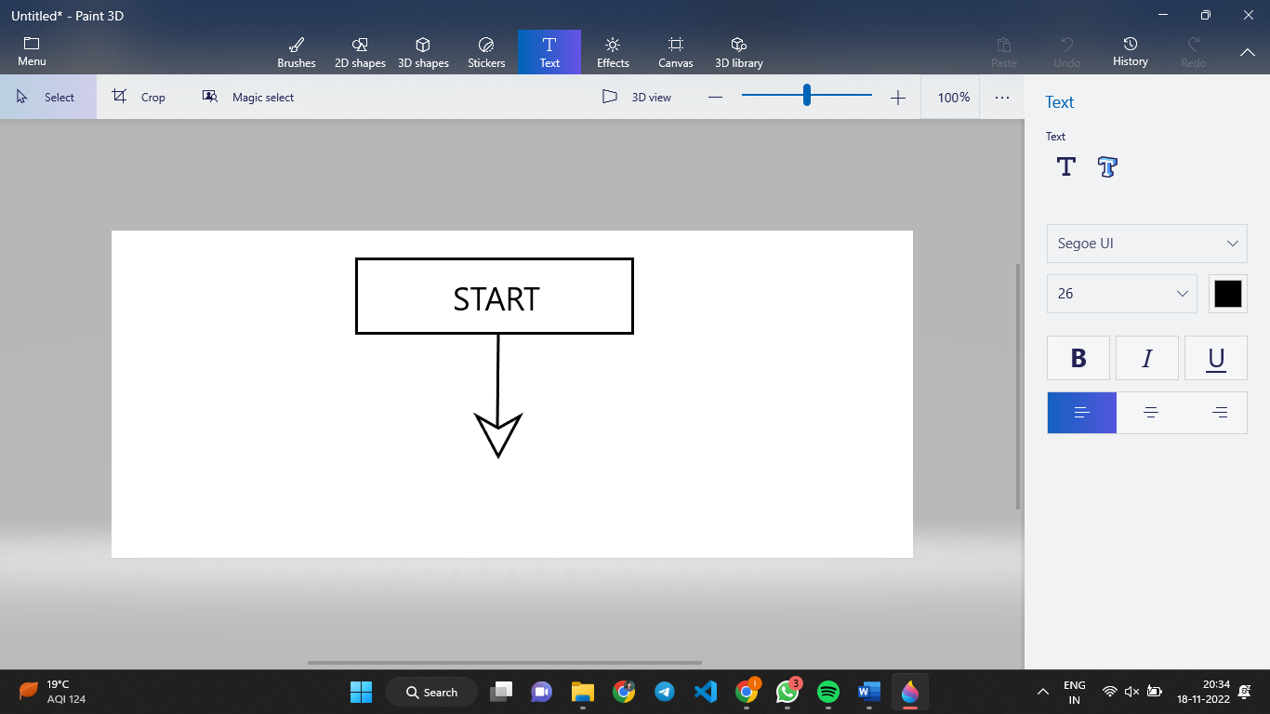

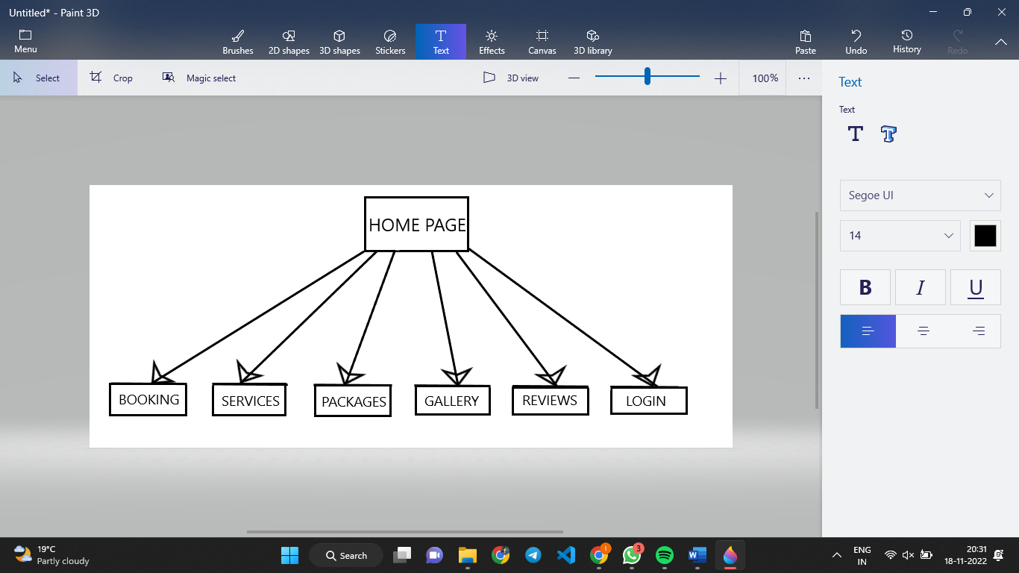

On the top left corner , there is logo of website named as BTRAVEL

The topmost Navigation bar consists of Logo, Search bar, login/sign-in

In center of webpage , there is a Home section where user can discover various places.

We can also navigate to different pages by clicking them on the navbar.

Home, book , packages , services, gallery , Reviews are also included in the navbar.

1. RESULTS AND DISCUSSIONS

a)Home page

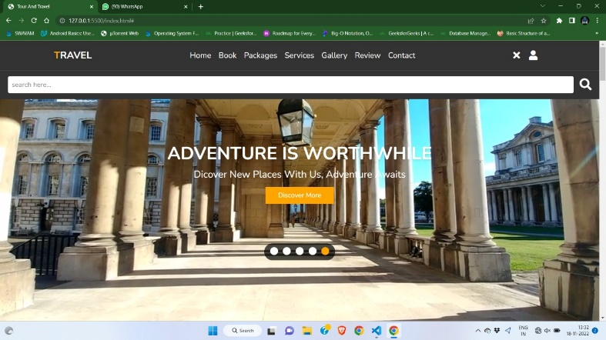

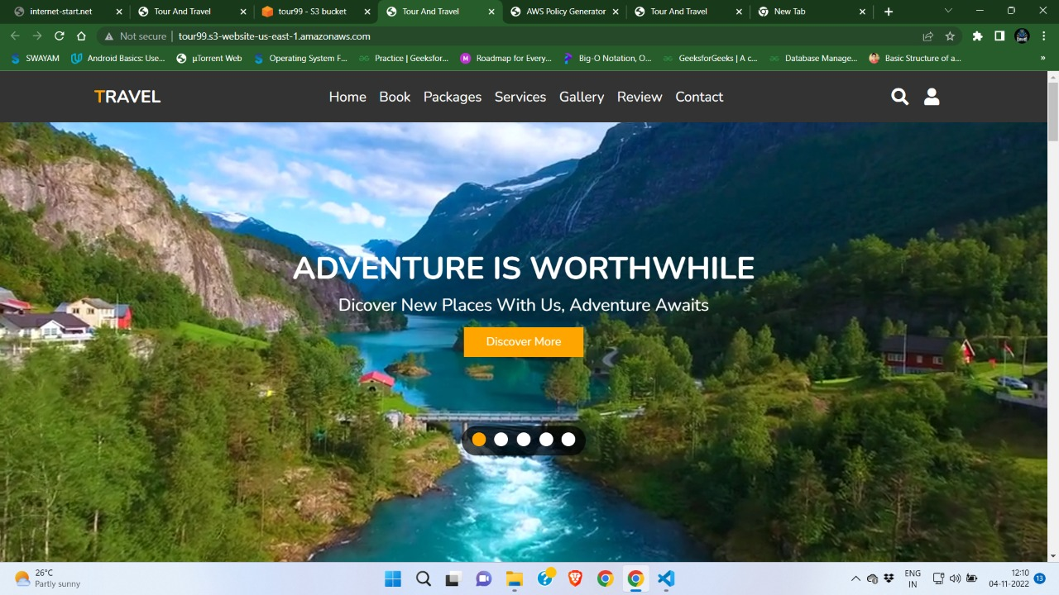

b)Log-in page 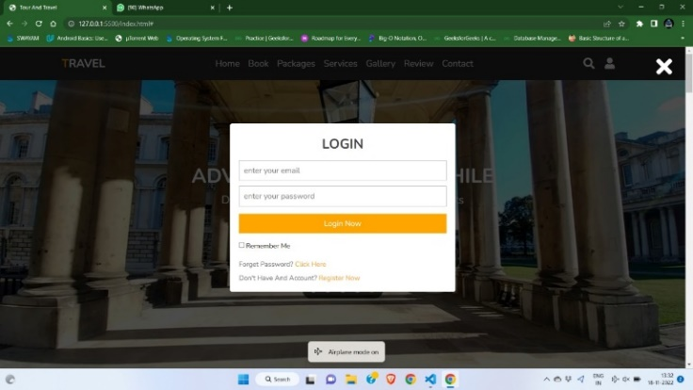

c)Booking page

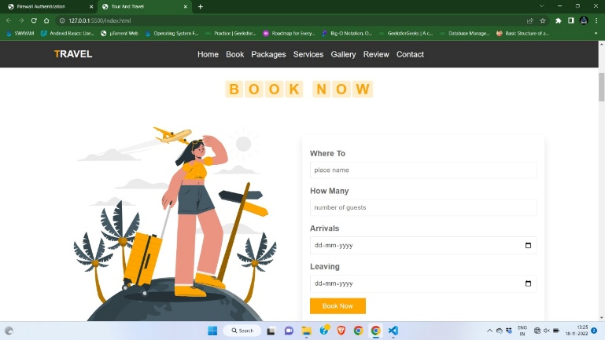

d)Services provided

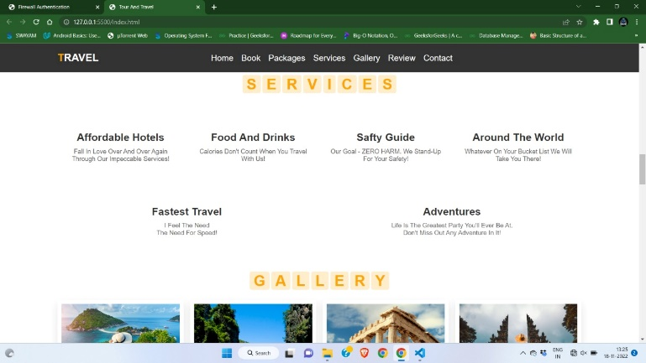

e)Packages available

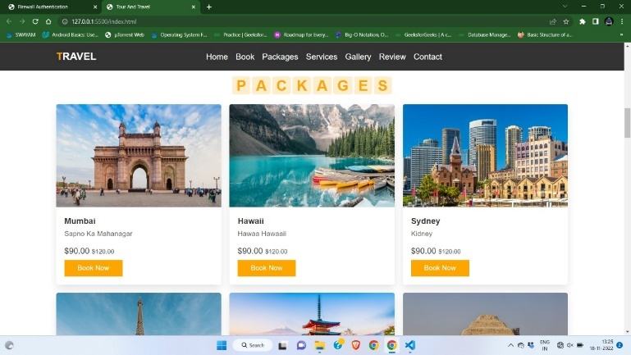

f)Gallery for various locations

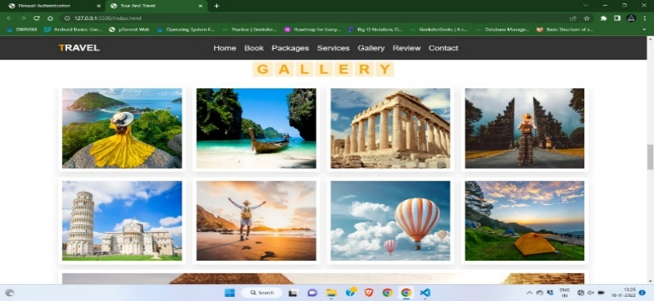

g) Review of old Users

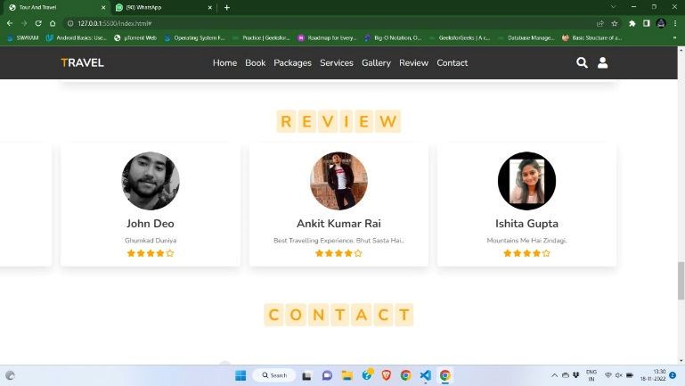

h)For any query , contact page

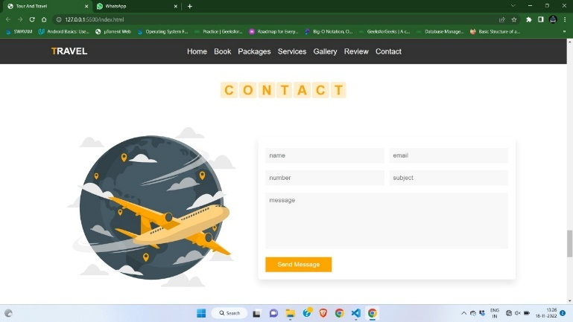

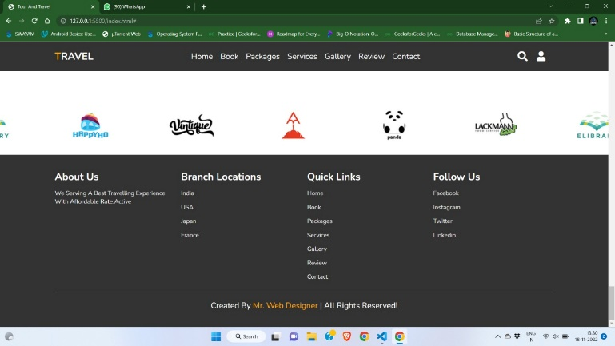

Our website will provide various functionalities for the user:

1. The topmost Navigation bar consists of Logo, Search bar,Sign-in/login:
2. The logo will represent the name of our social media.
3. The middle of the navbar consist of Home ,Book packages, services , gallery , review, contact:
4. The home option will lead the user from the current page to the home page.
5. Book Page will allow user to do booking according to their choice.
6. Packages page will provide user complete package of any location i.e. how much money is required, lodging etc.
7. Services page displays all the services that have been provided by our travel site
8. Gallery contains the images of various famous monuments , beaches , seas etc.
9. Review section displays the reviews or experience of our clients
10. In contact page if any query is there one can contact to our team
11. The right side of the Webpage will provide various functionalities for the user like sig-in/login page , and search bar:
12. The search bar helps the user to find the desired places with ease.
13. A user can login to their account or sign-in using email-address

IV. CONCLUSION

The AWS architecture is highly available and scalable, secure, and provides for a responsive user experience at very low cost. By enabling and analyzing the available logs, you can you understand your visitors and how well the website is performing. Fewer moving parts means less maintenance is required. In addition, the architecture costs only a few dollars a month to run

The tourism industry is extremely diverse – from the size of organization; business type; sector; organization; and process. It can be taken as the collection of various industries

This type of software’s can be further extended –

* For generating reviews related to the tourist requirements.

• Can be used for generating reviews for the Online Videos provided on the software.

• Easy to find the nearby famous places, temples & monuments.

• Developer can be providing the update information of the places and also provide updates to the software for better serves.

•Provide offers for various places in budgets occasionally

REFERENCES

1. "How Cloud Computing Works", [Online]. Available: http://computer.howstuffworks.com/cloudcomputing/cloud-computing.htm
2. Te-Shun C., 2013, "Security Threats on Cloud Computing Vulnerabilities", International Journal of Computer Science & Information Technology (IJCSIT) Vol 5, No 3.
3. Serrano N., Gallardo G., and Hernantes J., 2015, “Infrastructure as a Service and Cloud Technologies”, IEEE Softw., vol. 32, no. 2, pp. 30–36.
4. Narula S., Prachi M., Jain A., 2015, "Cloud Computing Security: AWS", In Proceedings of Fifth International Conference on Advanced Computing & Communication Technologies
5. "Nessus", [Online] Available:
6. http://www.tenable.com/products/nessus/select-youroperating-system
7. "ClamAV", [Online] Available: https://www.clamav.net/downloads
8. Sullivan B. (2016). “Amazon Web Services Public Cloud”, [Online]. Available: http://www.techweekeurope.co.uk/cloud/cloudmanagement/amazon-web-services-public-cloud185687
9. "How to secure your Amazon EC2", Amazon Inc. about Amazon web services, [Online] Available: <http://aws.amazon.com/articles/1233>
10. [4]. Mutch, J., "How to Steal Data from the Cloud", 2010, [Online]. Available: http://www.cloudbook.net/resources/stories/how-tosteal-data-from-the-cloud
11. [5]. Archer J. (2010), “Top Threat to Cloud Computing”, Cloud Security Alliance. [Online]. Available: https://cloudsecurityalliance.org/topthreats/csathreats.v 1.0.pdf
12. [6]. Kirchgaessner S. (2013), Cloud Storage Carries Potent Security Risk, [Online]. Available: http://www.ft.com/cms/s/0/4729ed7c-3722-11e3-9603- 00144feab7de.html
13. [7]. Simonite T (2012) “How to steal data from your neighbor in the cloud”. MIT Technology Review, 8 Nov 2012. www.technologyreview.com/news/506976/howto-steal-data-from-your-neighbor-in-the-Cloud/
14. [8]. Hanim. E. (2013), “Security threats and solutions in cloud computing,” in 2013 World Congress on Internet Security, WorldCIS 2013, 2013, pp. 139–143.
15. [9]. “AWS Market Share Reaches Five-Year High Despite Microsoft Growth Surge", (2015) [Online]. Available: https://www.srgresearch.com/articles/aws-marketshare-reaches-five-year-high-despite-microsoft-growthsurge